HashSet vs ArrayList
Choosing the Right Collection: Duplicate Login / IP Tracking vs Ordered Shopping Cart

1. Overview
Java's Collections Framework offers many ways to store groups of objects, but two of the most commonly compared are HashSet and ArrayList. They solve different problems, and picking the wrong one can hurt both correctness and performance. This document walks through a concrete industrial example — preventing duplicate user logins / tracking IP addresses with a HashSet — contrasted with maintaining an ordered shopping cart using an ArrayList.

2. Industrial Example
Preventing duplicate user logins or IP tracking using HashSet, versus maintaining ordered shopping cart items with ArrayList.

2.1 HashSet — Duplicate Login / IP Tracking
A login-security system needs to know instantly whether an IP address has already attempted to log in — for example, to block repeated automated attempts or flag suspicious activity. Two requirements dominate:
- Uniqueness: the same IP must never be stored twice.
- Speed: with potentially millions of login attempts, checking "have I seen this before?" must be fast.
A HashSet is built exactly for this. It stores elements in hash buckets determined by hashCode(), and add() silently returns false if an equal element already exists — no duplicate is ever inserted. Because lookups go straight to a bucket instead of scanning every element, both add() and contains() run in O(1) average time.
Set<String> loginIPs = new HashSet<>();
boolean isNewIP = loginIPs.add(incomingIP);
if (!isNewIP) {
blockLogin(incomingIP); // duplicate detected instantly
} else {
allowLogin(incomingIP);
}
For custom objects (e.g. a User record combining IP + timestamp), HashSet relies on the equals() and hashCode() contract: two objects that are equal() must produce the same hashCode(), or duplicates will slip through undetected.

2.2 ArrayList — Ordered Shopping Cart
A shopping cart has the opposite requirements. The order items were added matters — it's usually shown to the user in that sequence — and duplicates are completely normal (a shopper can add "Wireless Mouse" twice for two units).
- Order matters: item 1 must stay before item 2.
- Duplicates are expected and meaningful, not an error.
- Items are often accessed or updated by position (e.g. "update quantity of item at index 2").
An ArrayList is a perfect fit: it is a resizable, indexed array that preserves insertion order and allows repeated values. get(index) is O(1), making it efficient for displaying or editing the cart in sequence.
List<String> cart = new ArrayList<>();
cart.add("Wireless Mouse");
cart.add("USB-C Cable");
cart.add("Wireless Mouse"); // duplicate allowed
System.out.println(cart.get(0)); // "Wireless Mouse" — order preserved

3. What Happens If You Don't Use a HashSet?
Skipping duplicate/uniqueness tracking altogether — or using the wrong structure for it, like an ArrayList — doesn't just risk letting duplicates through. It changes how the check performs as data grows, which matters most exactly when it's needed most: during an attack.

3.1 No tracking at all
If login attempts are processed without checking against previously seen IPs, nothing stops the same IP from attempting logins thousands of times per second. Each attempt is treated as brand new, so brute-force attacks and credential-stuffing bots go completely undetected.

3.2 Using an ArrayList instead of a HashSet
This is the more instructive failure mode, because the code still "works" — it's just slow in a way that gets worse over time:
- contains() on an ArrayList scans every element one by one — O(n) time.
- If 50,000 IPs are already tracked, checking one new IP can mean up to 50,000 comparisons.
- A HashSet performs the same check in O(1) average time — it jumps straight to the right bucket instead of scanning.
- An ArrayList also allows duplicate IPs to accumulate, which makes every future scan even slower.
// Without HashSet — gets slower as the list grows
List<String> seenIPs = new ArrayList<>();
if (seenIPs.contains(incomingIP)) { // scans every element
blockLogin(incomingIP);
}
// With HashSet — stays fast regardless of size
Set<String> seenIPs = new HashSet<>();
if (!seenIPs.add(incomingIP)) { // O(1) average
blockLogin(incomingIP);
}

3.3 Real-world consequences
- Brute-force and credential-stuffing attacks aren't caught in time.
- Under high-volume attack traffic, the slow duplicate check itself can overwhelm the server — the defense mechanism becomes part of the outage.
- Legitimate users experience slower login response times as the tracked-IP list grows.
- The very moment detection speed matters most (an active attack) is when an O(n) scan is at its slowest.
The diagram below contrasts both approaches directly: a linear scan through every tracked IP versus a direct hash-bucket lookup.
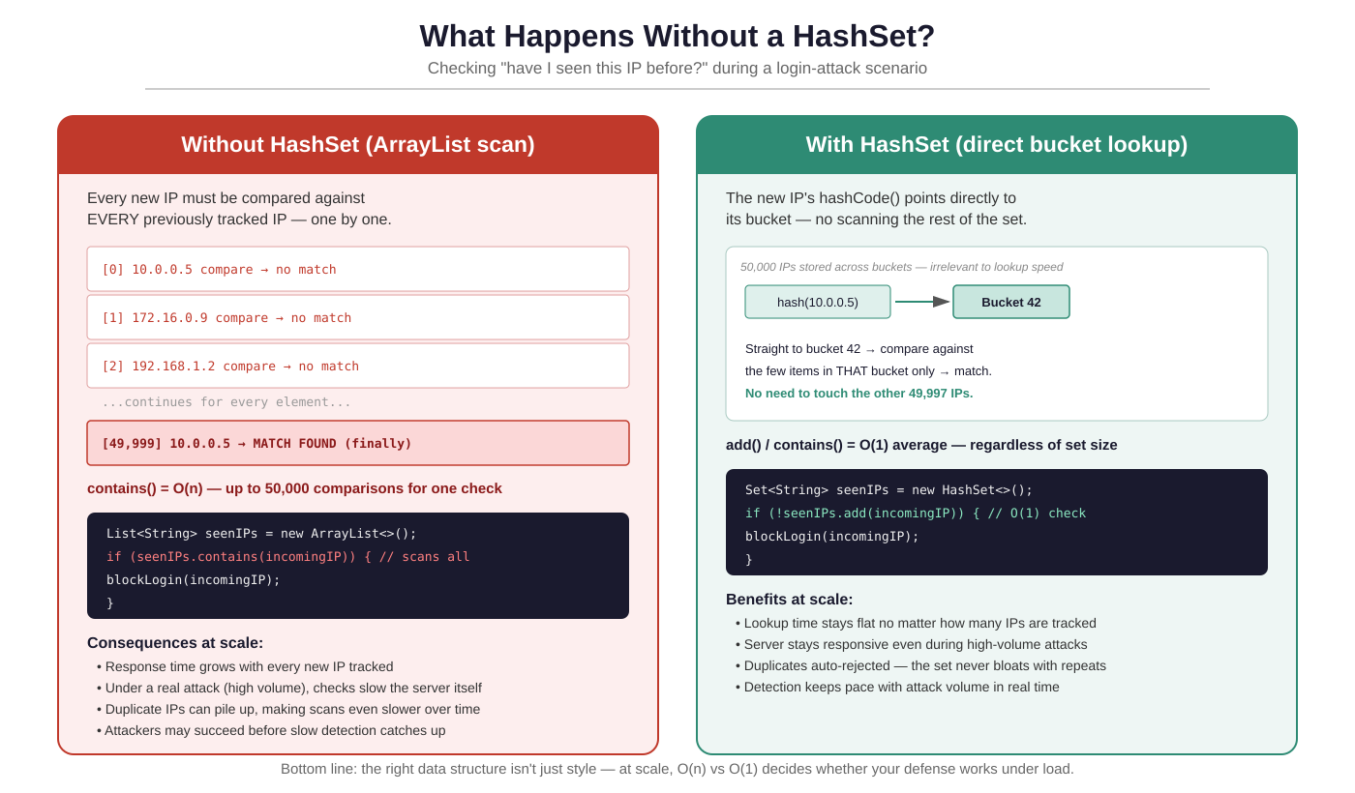

4. What Happens If You Don't Use an ArrayList?
The reverse mistake also happens: using a HashSet for the shopping cart instead of an ArrayList. Because HashSet solves a different problem (uniqueness + fast lookup), forcing it into a cart role breaks the two things a cart actually needs — order and duplicates — at the same time.

4.1 Duplicates silently disappear
A shopper adding "Wireless Mouse" to the cart twice (intending to buy two units) will find only one Mouse in the cart. HashSet.add() returns false for an element that's already present and simply does not store it again — there is no error, no warning, just a quietly lost item and a quietly lost sale.

4.2 Order is not preserved
HashSet makes no guarantee about iteration order — items are placed according to their hash value, not according to when they were added. A cart displayed by iterating a HashSet can show items in a different order every time, which is confusing for the shopper and breaks any UI that assumes "first added, first shown."

4.3 No positional access
A HashSet has no get(index) method. Any feature that needs to reference "the second item in the cart" — editing quantity, removing a specific line, or showing line numbers on a receipt — has no direct way to do that on a HashSet.
// Using HashSet for a cart — breaks order and duplicates
Set<String> cart = new HashSet<>();
cart.add("Mouse");
cart.add("Cable");
cart.add("Mouse"); // returns false — 2nd unit is lost
// cart.get(0) does not exist — no indexed access
// Using ArrayList for a cart — works as expected
List<String> cart = new ArrayList<>();
cart.add("Mouse");
cart.add("Cable");
cart.add("Mouse"); // kept — size = 3
cart.get(0); // "Mouse" — reliable, ordered access

4.4 Real-world consequences
- A customer who wants 2 units of an item is silently charged/shown for only 1.
- The cart display order becomes unpredictable, undermining user trust in the UI.
- Editing or removing a specific line item by position becomes impossible.
- Checkout summaries and receipts can no longer reliably reflect what was actually added, in what order.
The diagram below compares both directly: the same sequence of adds behaves correctly in an ArrayList but loses data and order in a HashSet.
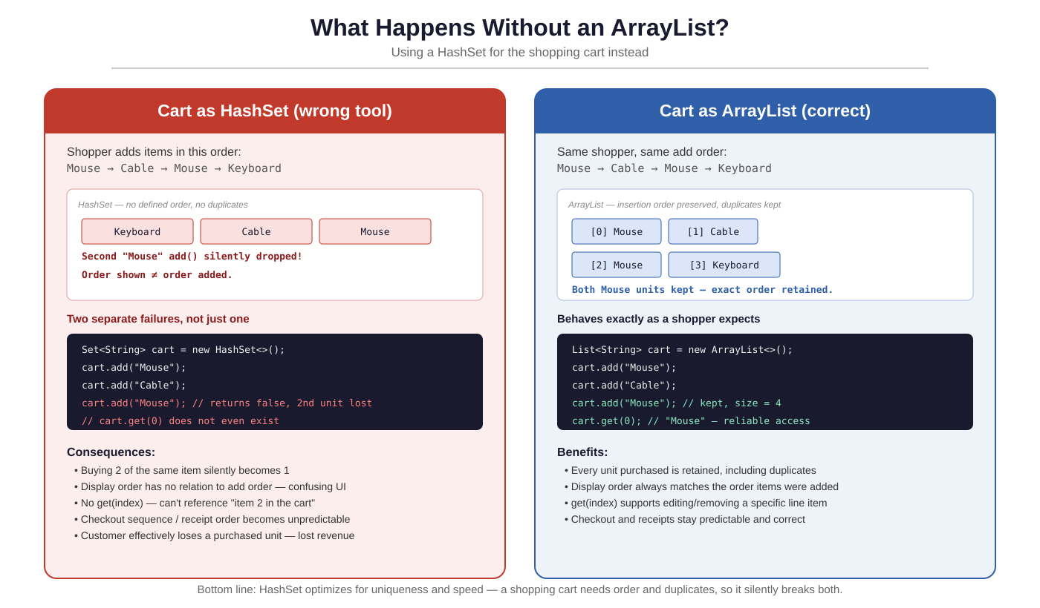

5. Visual Comparison
The diagram below illustrates both scenarios side by side: hash-bucket-based duplicate rejection on the left, versus an ordered, index-based list that allows duplicates on the right.
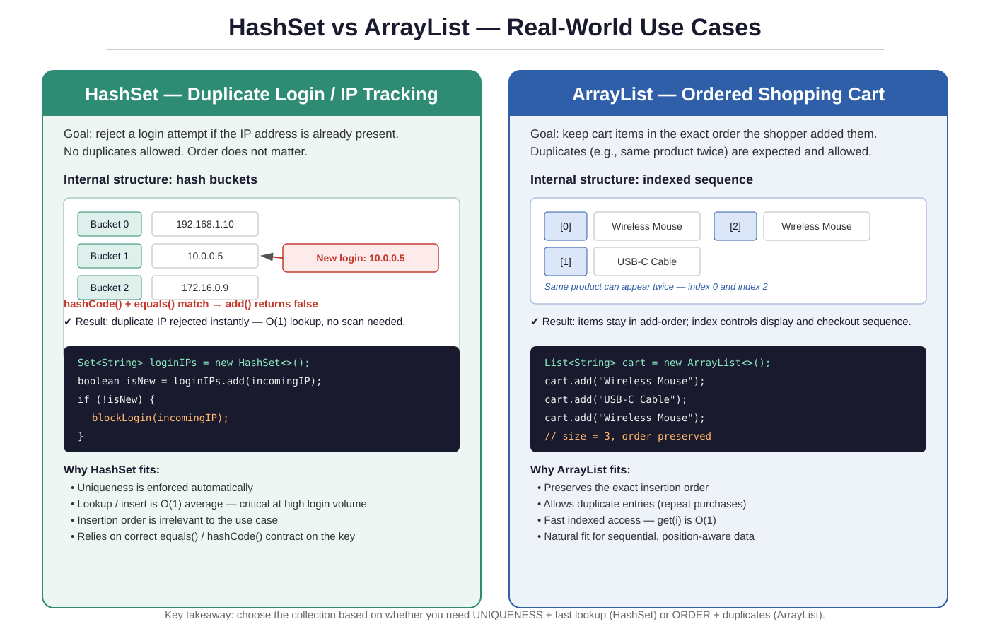

6. Side-by-Side Comparison Table
Aspect | HashSet | ArrayList
Underlying structure | Hash table (buckets keyed by hashCode()) | Resizable array, indexed by position
Duplicates | Not allowed — rejected via equals()/hashCode() | Allowed — same value can repeat
Order | No guaranteed order (insertion order not preserved) | Insertion order strictly preserved
Lookup / contains() | O(1) average | O(n) — must scan sequentially
Access by position | Not supported (no get(index)) | O(1) via get(index)
Typical use case | Uniqueness checks: duplicate logins, IP tracking, tag sets | Sequenced collections: shopping cart, playlists, order history
Required override | equals() and hashCode() on custom objects | equals() only if using contains()/indexOf() with objects

7. Key Takeaway
Choose a HashSet when the priority is uniqueness and fast lookup and order doesn't matter — such as tracking IP addresses, blocking duplicate logins, or de-duplicating tags. Choose an ArrayList when the priority is preserving insertion order and allowing repeated values — such as a shopping cart, a playlist, or an order history log. Selecting the right collection up front avoids both subtle bugs (unwanted duplicates, or lost ordering) and unnecessary performance costs (linear scans where a hash lookup would do).

